**JOB ANALYSIS REPORT**

*for the classification of*

**Peer Tutor (Content)**

The University at Albany, State University of New York

March 2021

Academic Support Center

University at Albany

*1400 Washington Avenue*

*Albany, NY 1222*

Table of Contents

Listing of Appendices 1

Introduction 2

User, Location, and Dates of Study 3

User 3

Location of Study 3

Dates of Study 3

Problem and Setting 4

Purpose of Study 4

Classification Concept 4

Job Analysis for Peer Tutor (Content) 5

Method Used to Analyze Job 5

Literature Review 5

Interview 5

Identification of Work Behaviors 5

Measures of Criticality 6

Task Rating Scales 6

Competency Rating Scales 6

Sample Characteristics 7

Data Analysis 8

Rater Quality 8

Questionnaire Results 8

Task Ratings 8

Competency Ratings 9

Task-Competency Linkage Scale 10

Key Findings 11

Future Selection Procedures 11

Accuracy and Completeness 12

Contact Person 13

References 14

Appendices 15

# Listing of Appendices

1. Job Analysis Questionnaire (As Seen by Respondents)
2. Task-Competency Linkages Questionnaire (As Seen by Respondents)
3. Task Rating Results
4. Competency Rating Results
5. Eliminated Competencies and Rating Results
6. Interview Notes
7. Task-Competency Linkages Results
8. Task-Competency Linkages Mean Ratings

# Introduction

The Federal *Uniform Guidelines on Employee Selection Procedures (Uniform Guidelines)* require that selection processes be demonstrably related to the actual job requirements for which the selection procedures are being used. Due to changing job requirements, due in part to advancing communication and pedagogical technology, job analyses should be performed on jobs where interpersonal communication and education are important to effective job performance. This job analysis was conducted in accordance with guidance found in the *Uniform Guidelines* as well as other best practices as recommended by experts in the field of job analysis.

This format, layout, and some of the wording of this report are based on recommendations found in the California State Personnel Board’s *Merit Selection Manual: Policy and Procedures* (Appendix H; <https://www.spb.ca.gov/content/laws/selection_manual_appendixh.pdf>).

# User, Location, and Dates of Study

## User

The Peer Tutor (Content) job classification is widespread, but the study herein described was conducted for the Peer Tutor (Content) job classification as used by the Academic Support Center at the University at Albany.

## Location of Study

This study was completed by a student at the University at Albany, State University of New York. The interview was conducted using the Zoom video communication application, and the survey was administered using the Qualtrics online survey platform.

## Dates of Study

The study began in February 2021 and ended in March 2021.

# Problem and Setting

## Purpose of Study

The *Uniform Guidelines* outline the requirements necessary for employers to legally defend employment decisions based upon both overall selection processes and individual selection procedures. The purpose of this study was to determine the actual requirements for peer tutors who tutor in content areas, a job designated ‘Peer Tutor (Content)’ throughout this report, as utilized by the Academic Support Center at the University at Albany.

## Classification Concept

The Peer Tutor (Content) classification is used to classify positions which may perform part, or all, of the following duties: teach students study skills and class content, using the students’ own class materials; provide private instruction to individual or small groups of students to improve academic performance; review class material with students by discussing class material and working solutions to problems; and similar, related tasks.

The Peer Tutor (Content) classification is not intended to comprehend the job requirements for general subject tutors, such as Math or Writing tutors. Tutors tutoring broad subjects have many similar job requirements as the Peer Tutor (Content) classification, but these positions also have additional requirements regarding knowledge of broader subject areas, and their specific job duties may differ, requiring employees to employ different strategies, using different knowledge, skills, abilities, and other characteristics (KSAOs), to accomplish the job requirements. In this report, KSAOs are called competencies.

# Job Analysis for Peer Tutor (Content)

## Method Used to Analyze Job

The job analysis methodology used for this project utilized a Task Inventory (TI) method. TI was chosen because it was rated most the most effective method for generating job descriptions, and was associated with the highest quality of outcomes, by experienced job analysts (Levine et al., 1983). TI is also a form of task analysis, which is designated in the *Uniform Guidelines* as an acceptable method for job analysis. This study’s methodology included (1) a review of general tutoring requirements on O*NET[1], an online repository containing descriptions of tasks and competencies requisite for many different jobs; (2) an interview with a former tutor to get a better understanding of tutoring and the tasks and competencies required to fulfill the job’s responsibilities; (3) the creation and administration of a job analysis questionnaire, consisting of tasks and competencies taken from O*NET and the interview, to other former tutors; (4) the completion of a task-competency linkages by the study’s author; and (5) an analysis of questionnaire data to determine the essential tasks required of the Peer Tutor (Content) job classification.

Although experts (Guion, 2019) note that it is ideal to also interview supervisors who manage those working with the job classification, study authors were unable to complete such interviews, due to the time frame and scope of the current job analysis.

## Literature Review

One of the first steps in job analysis is to conduct a literature review on the job classification requirements. For this analysis, O*NET was used to gather information on task requirements and competencies needed for those working in a Peer Tutor (Content) classification. The study’s author also drew on his own experience working as a Peer Tutor (Content). An initial pool of task requirements and competencies was created with this information.

## Interview

A semi-structured interview was conducted with a former tutor. Interview questions were created beforehand, and the interview’s flow proceeded according to both the predetermined questions and asking organic questions that arose during the interview. *Appendix F* includes the interview questions and final interview notes.

## Identification of Work Behaviors

The initial pool of task requirements and competencies was updated with information obtained in the interview, and the job questionnaire was created. *Appendix A* includes a copy of the final version of the Peer Tutor (Content) job analysis questionnaire, as well as the rating scales used for the task and competency statements.

# Measures of Criticality[2]

Screenshots of the survey, as respondents viewed it on their computers, can be found in *Appendix A.* The tasks and competencies were evaluated using the rating scales described as follows:

## Task Rating Scales

Questionnaire respondents rated each task statement on its criticality and relative time spent performing each task. Independent rating scales were used to evaluate each task statement. The Task Scales both contained a ‘bogus’ task (“Help students manage their personal finances, using modern budgeting software, to ensure students can pay the tutor in a timely fashion.”). Bogus tasks are meant to ensure that raters are paying attention and not responding randomly; both raters gave the bogus task an appropriately low rating (i.e., “Not Performed”).

***Task Scale A: Importance***

This scale first identifies the essential functions of the job and then measures the importance of those essential functions to overall successful job performance. Scale responses range from 0 (Not Performed) to 5 (Extremely Important). Tasks with average importance ratings of a 3 (Important) or higher are acceptable for the focus of selection procedures designed to assess applicant skill at job tasks.

***Task Scale B: Frequency of Performance***

This scale assesses the relative time spent performing each task of the job. Scale responses range from 0 (Not Performed) to 5 (Extremely Important).

## Competency Rating Scales

Questionnaire respondents rated each competency statement on its importance and the amount of the competency required upon entry to the job. Independent rating scales were used to evaluate each competency statement.

***Competency Scale A: Importance Scale***

This scale assesses the importance of a competency to overall successful job performance. Scale responses range from 1 (Not Important) to 5 (Extremely Important). Competencies with average importance ratings of a 3 (Important) or higher should be the focus of selection procedures designed to assess competence to perform the job.

***Competency Scale B: Need at Entry Scale***

This scale assesses how much of a competency is required upon appointment (or entry) to the job. Scale responses range from 1 (Needed the first day) to 4 (Must be acquired after the first 6 months). Competencies which receive a mean rating of 1.5, indicating that possession of the competency is required or strongly encouraged upon entry to the job, are suitable for consideration in the selection process.

***Competency Scale C: Distinguishing Value Scale***

This scale assesses how valuable the competency is in distinguishing superior from barely acceptable employees. This scale is used to identify those competencies of which increased amounts improve job performance. The information obtained from this scale provides the rationale for ranking candidates who score above minimum levels in the selection process. Scale responses range from 1 (Not Valuable) to 5 (Extremely Valuable).

## Sample Characteristics

Questionnaires were emailed to two graduate students in the Industrial-Organizational Psychology program at the University at Albany, who completed the questionnaires anonymously. Both respondents completed all scale questions, making the response rate 100%. The study’s author, who completed the third competency scale, was a third graduate student in the same program.

# Data Analysis

Questionnaire responses were automatically recorded by the Qualtrics survey platform. The responses were downloaded, and the study author used the computer programming language R to analyze the data. Descriptive statistics (i.e., means and standard deviations) were calculated for each scale and are provided below.

## Rater Quality

Rater consistency is of interest to job analysis studies because consistency is an indicator that raters have similar understandings of job requirements. If different raters have very different beliefs about what a job entails, it may not be appropriate to use their ratings, as this may suggest that the actual job experiences of the raters are too different to both be relevant to the job being classified.

Interrater agreement is a measure of how often that raters give an item the same rating, or a rating that is within a specified range (called the tolerance). For Likert-type scales it is reasonable to set the tolerance to one, meaning that two raters are counted as agreeing so long as they score the same item within one scale point of each other; e.g., if one rater rates an item a ‘3’ and the other rater rates the item a ‘4’. R was used to calculate the degree of consistency between the two raters. Using a tolerance of one, the two raters had an interrater agreement of 78.8%, including all scores. Analyzing the items which the respondents disagreed by 2 or more scale points on showed no consistent pattern in which items respondents disagreed on.

Although an interrater agreement of 78.8% is not ideal, there is no absolute rule about minimum acceptability of interrater agreement. The study author believes that this level of agreement suggests that the raters’ understandings of the job were close enough to warrant inclusion of both of their ratings in this study[3]. However, future studies should include frame-of-reference training for respondents and collect more background information about their demographic information, length of tenure working as a tutor, and the context of their work as a tutor (e.g., were they independent or did they work for a college, what subjects did they specifically tutor, etc.) to contextualize significant differences in scale scores.

## Questionnaire Results

Descriptive statistics summarizing the task and competency ratings are presented below. Complete results of the task and competency scales can be found in *Appendix C* and *Appendix D*, respectively.

## Task Ratings

On the importance scale, a mean rating of 0 (Not Performed), 1 (Not Important), or 2 (Somewhat Important) would signal that the task was either unimportant or not very important to the job and should not be considered an essential skill. Of the 14 tasks originally rated, 13 received mean ratings higher than 2.0 on the Task Importance scale. These tasks were analyzed using the scales described below.

***Task Scale A (Importance)***

Of the 13 essential tasks, 3 tasks received mean Scale A ratings of 5 (Extremely Important); 4 tasks received mean ratings between 4.0 and 4.9 (Very Important), and 6 received a mean rating between 3.0 and 3.9 (Important). The mean rating of essential tasks was 3.92 (Important).

***Task Scale B (Frequency)***

Of the 13 essential tasks, 1 task received a mean rating between 4.0 and 4.9 (Every few hours to daily), 2 tasks received mean ratings between 3.0 and 3.9 (Every few days to weekly), 7 received mean ratings between 2.0 and 2.9 (Every few weeks to monthly), and 3 tasks received mean ratings between 1.0 and 1.9 (Every few months to yearly). Not tasks received mean ratings of 5 (Hourly to many times each hour) or below 1 (which would represent a task not performed). The mean rating of essential tasks was 2.5 (Every few weeks to monthly).

## Competency Ratings

***Competency Scale A (Importance)***

Of the 19 competencies, 4 competencies received a mean rating of 5 (Extremely Important), 7 competencies received a mean rating between 4.0 and 4.9 (Very Important), 7 competencies received a mean rating between 3.0 and 3.9 (Important), and 1 competency received a mean rating between 2.0 and 2.9 (Somewhat Important). No competency received a mean rating less than 2.5 (Somewhat Important). 18 competencies had mean ratings of 3.0 or higher and were deemed important for successful job performance.

***Competency Scale B (Need at Entry)***

Of the 19 competencies, 10 competencies received a mean rating between 1.0 and 1.9 (Needed the first day), 6 competencies received a mean rating between 2.0 and 2.9 (Must be acquired within the first 3 months), and 2 competencies received a mean rating between 3.0 and 3.9 (Must be acquired within the first 4-6 months). 10 competencies received a mean rating of 1.5 or lower, meaning that these competencies are important enough from the applicant’s first day of work to be considered when creating assessment procedures for this job classification.

A total of 10 competencies met or exceeded the Scale A cutoff of 3.0 while meeting or coming in below the Scale B cutoff of 1.5. For the purpose of job analysis and personnel selection procedures, these competencies can be considered for assessment.

***Competency Scale C (Distinguishing Value)***

Of the 10 competencies that satisfied the criteria for the Scale A and Scale B cutoffs, 4 received mean ratings of 5 (Extremely Valuable), 3 received mean values between 4.0 and 4.9 (Very Valuable), and 3 received mean values between 3.0 and 3.9 (Valuable).

*Appendix D*  contains information on the competency ratings for competencies that satisfied the criteria for being important and needed at entry, and *Appendix E* contains a copy of the eliminated competencies.

## Task-Competency Linkage Scale

This scale assesses how much each of the 13 essential tasks depends upon each of the 10 important competencies. The study author, who worked under the Peer Tutor (Content) classification for two years, completed this scale. The author rated how much each competency was required to successfully perform each task on a 1 (Not Important) to 5 (Extremely Important) scale. *Appendix G* contains the results of the scale. The means of the task-competency linkages varied by task and by competency; *Appendix H* contains the mean ratings of the linkages, by both tasks and competencies.

The mean ratings for tasks did not vary much—the mean of the mean ratings for tasks was 2.7, with a standard deviation of 0.36, and all but two tasks had a mean rating between 2.5 and 3 (‘Schedule tutoring appointments with students or their parents’ had a mean rating of 2, and ‘Identify, develop, or implement intervention strategies, tutoring plans, or individualized education plans for students to help optimize the student’s learning experience’ has a mean rating of 3.4). However, the mean ratings for competencies were much more variable; the mean of the mean ratings for competencies was again 2.7, but the standard deviation was 1.03. The primary reason for this was that four competencies (having a bachelor’s college degree, having a master’s college degree, having proficiency with Microsoft Word, and having proficiency with Microsoft Excel) had mean ratings of 2 or less, while all other competencies rated a 2.9 or above.

The disparity between the variability in the mean ratings of competencies and tasks likely points to a difference of opinion between the two sets of raters regarding the value of the four poorly rated competencies. (Indeed, removing those four competencies from the list changes the mean of the mean ratings for both tasks and competencies to 3.4 and the standard deviations to 0.49 [tasks] and 0.39 [competencies]).

The value of the task-competency linkage scale is that it can help identify how strongly applicant scores should be weighted for each task and competency. Analysts can use the gathered information to determine the weight each task and competency should be given, should they decide to weight those scores at all.

# Key Findings

Although this study only surveyed two subject matter experts (SMEs), and thus broad conclusions about the nature of the Peer Tutor (Content) classification cannot be made, certain patterns can be observed within the data.

Not surprisingly, the mean ratings for task importance and task frequency show a strong correlation (Pearson’s *r* = 0.90), meaning that SMEs were more likely to rate important tasks as being performed more frequently than less important tasks. This suggests that important tasks are both central to the job and make up a majority of what the job’s functions entail.

A similarly high correlation was found between the competency importance and competency distinguishing value scales (Pearson’s *r* = 0.94), suggesting that the competencies that are important for overall effective job performance are also those that distinguish superior from subpar workers. This correlation was statistically significant, which means that the correlation is likely not due to chance. A test for significance returned a *p*-value below 0.001 with 8 degrees of freedom (*df*), meaning that there is below of 0.01% likelihood that the correlation was due to chance. Weaker, non-significant correlations were found between the competency importance and competency need at entry scales (*r* = -0.51; *p* = 0.13, *df* = 8) and the competency need at entry and competency distinguishing value scales (*r* = -0.39; *p* = 0.26, *df* = 8). This suggests that not every important task competency needs to be present right away, and there is room for some competencies (e.g., perspective-taking, or the ability to see something from another’s point of view) to be acquired or improved within the first few months of employment.

***Competency scale correlations***

|  |  |  |  |
| --- | --- | --- | --- |
| **Scale** | **1** | **2** | **3** |
| 1. Importance | 1 |  |  |
| 1. Need at Entry | -0.51 | 1 |  |
| 1. Distinguishing Value | 0.94 | -0.39 | 1 |

## Future Selection Procedures

Although not within the purview of this study, it is possible to examine extant selection procedures using the data contained within this report. Because this analysis was not comprehensive, additional analyses should be consulted before the establishment of any selection procedures for the Peer Tutor (Content) job classification. Furthermore, future job analyses should collect pertinent demographic information from SMEs (age, sex, etc.) as well as how many years of experience they have had working as under the Peer Tutor (Content) job classification.

## Accuracy and Completeness

The job analysis documented in this report was conducted in a manner that conforms with the requirements of the *Uniform Guidelines*, except for the crucial factor of the sample size of SMEs surveyed. Additionally, it is good practice to also have the supervisors who supervise employees working under the Peer Tutor (Content) classification fill out ratings, to get a holistic picture of job requirements. Two SMEs is too small a pool of participants from which to generalize to the whole population of employees working under the Peer Tutor (Content) classification. Subsequent analyses should focus on gathering larger sample sizes.

# References

Guion, R. (2019). *Assessment, Measurement, and Prediction for Personnel Decisions* (2nd ed.)*.* Routledge.

Levine, E., Ash, R., Hall, H., & Sistrunk, F. (1983). Evaluation of job analysis methods by experienced job analysts. Academy of Management Journal, 26, 339-348. <https://www.jstor.org/stable/255981>

# Appendices

**Appendix A: Job Analysis Questionnaire (As Seen by Respondents)**

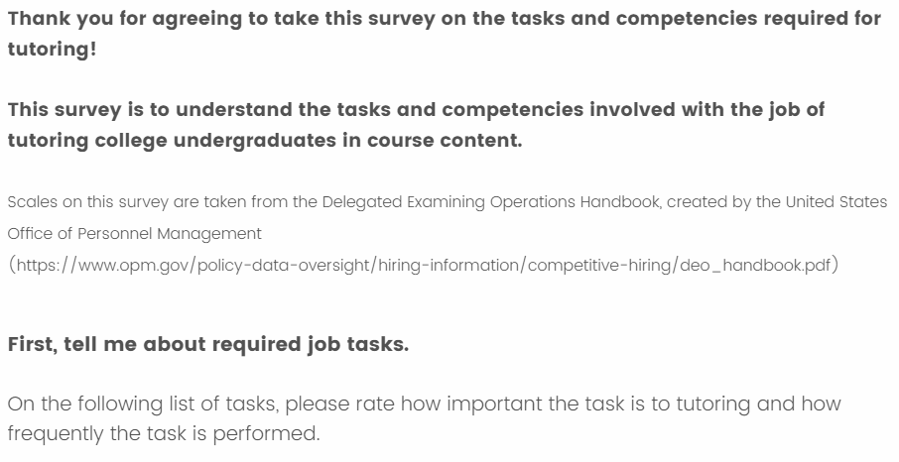

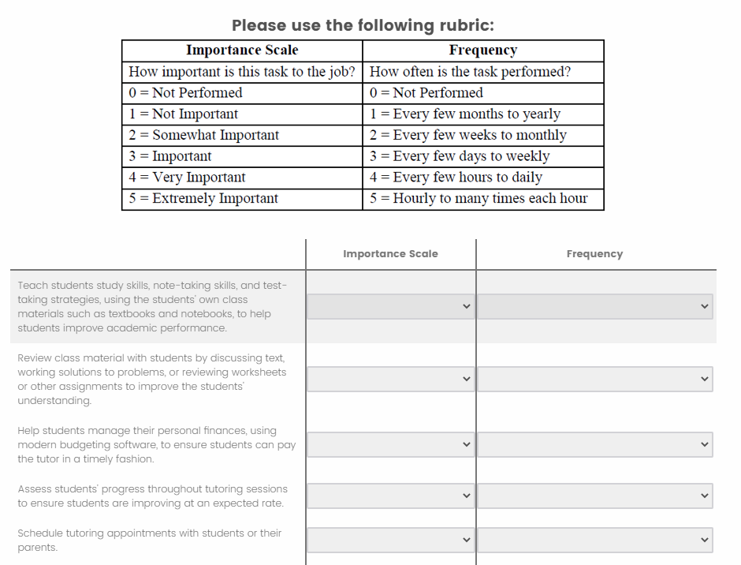

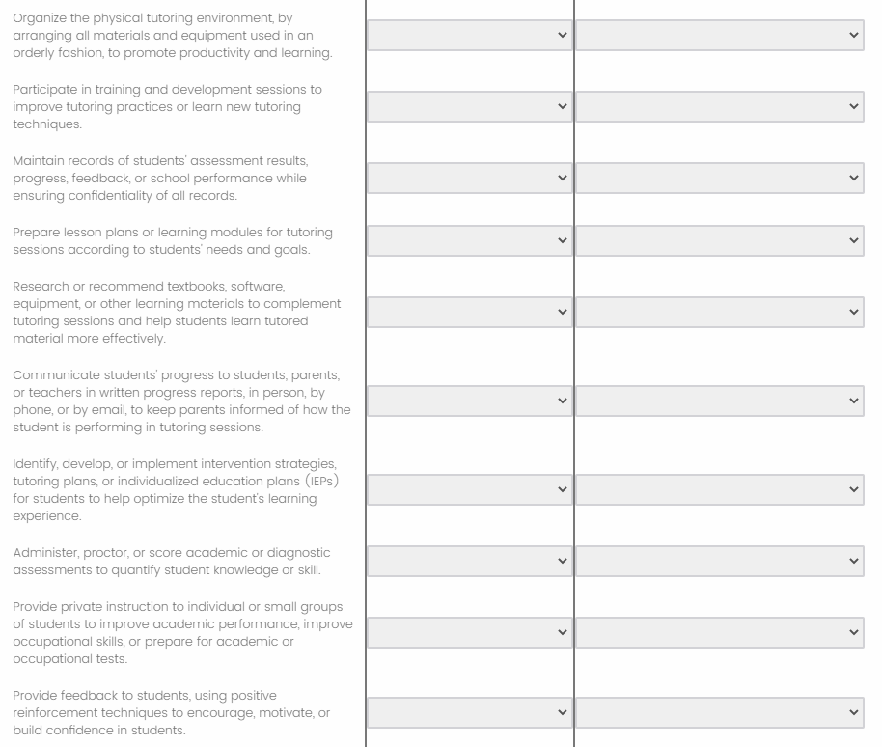

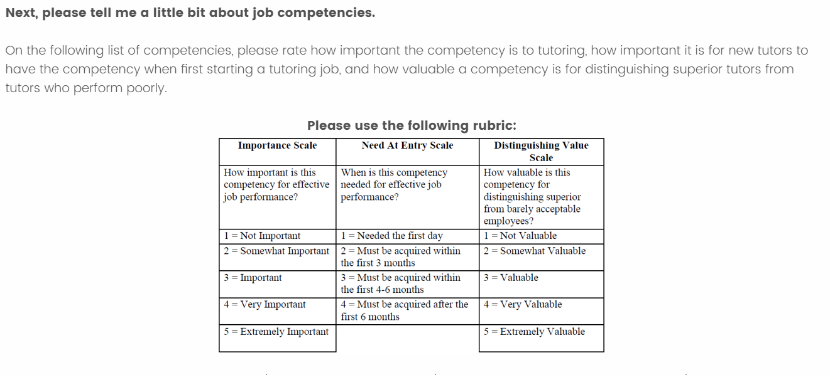

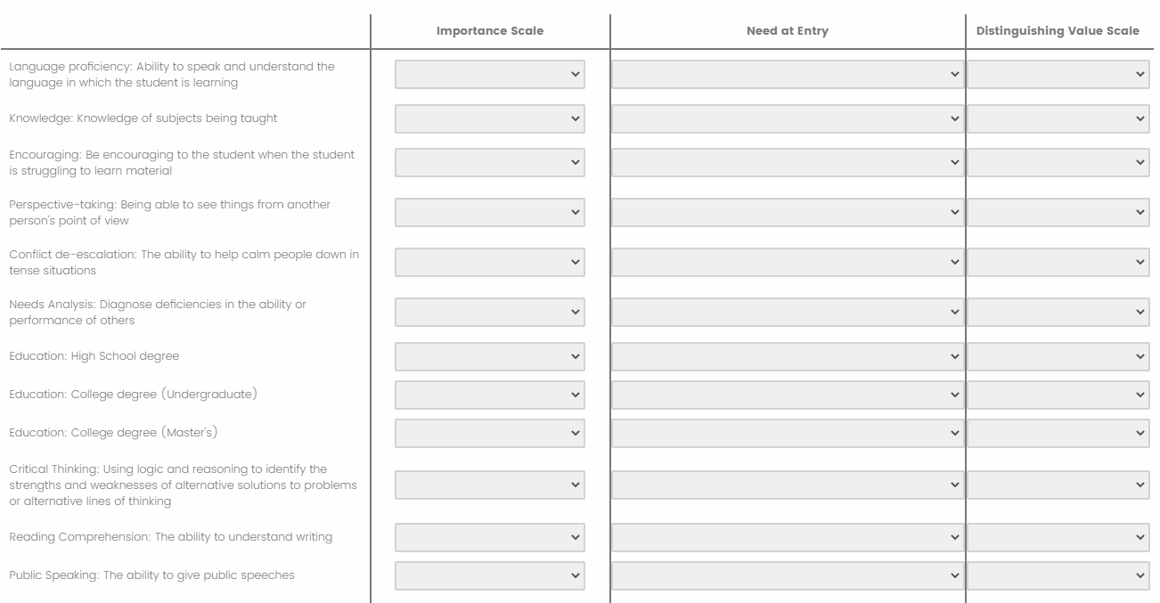

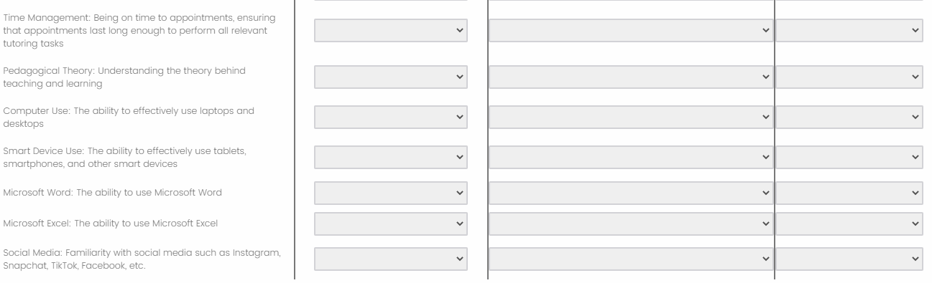

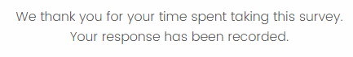

**Appendix B: Task-Competency Linkages Questionnaire (As Seen by Respondents)**

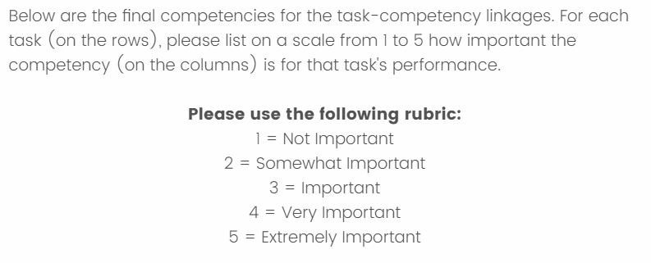

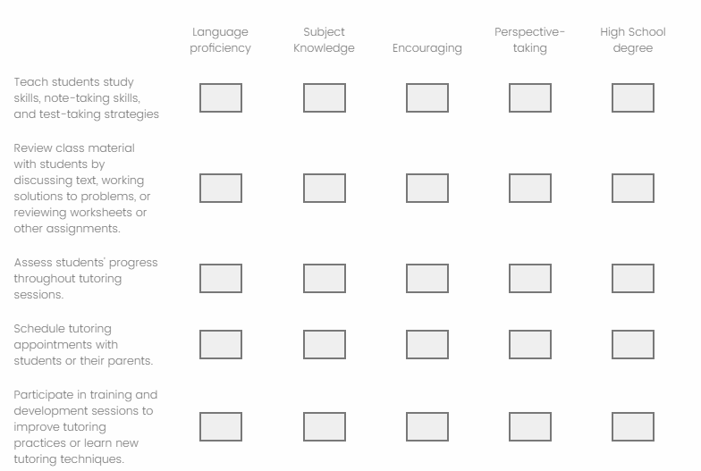

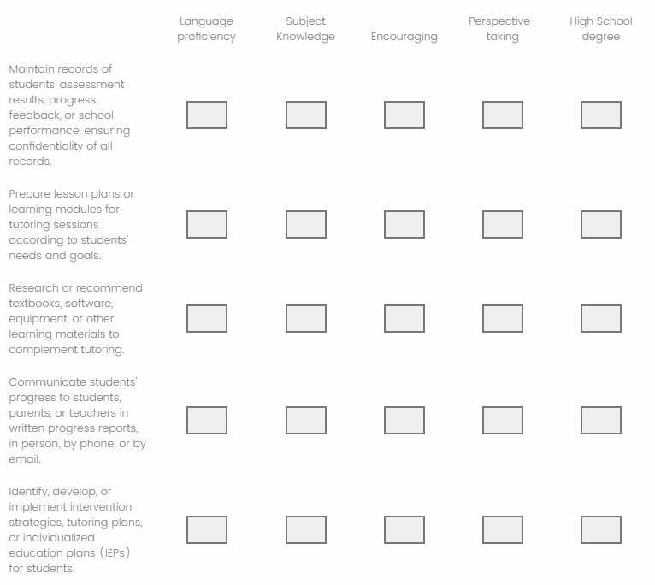

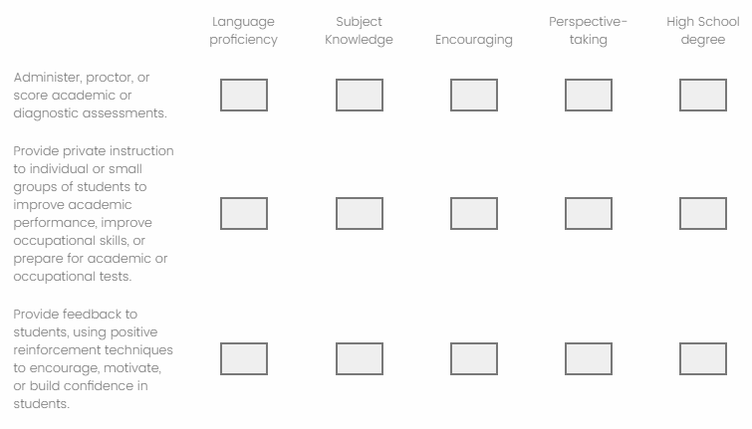

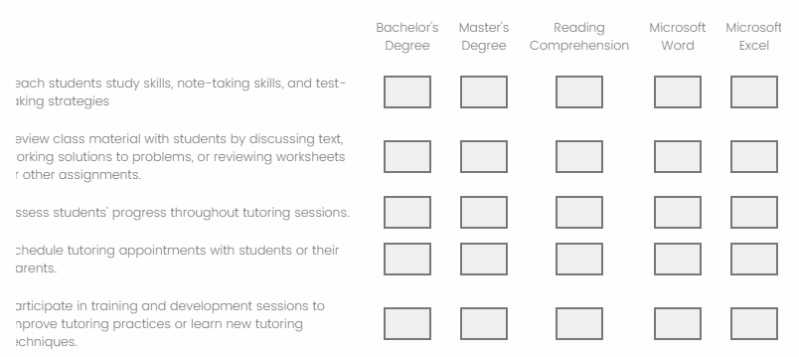

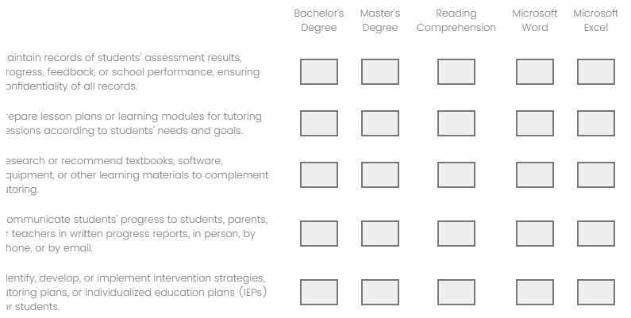

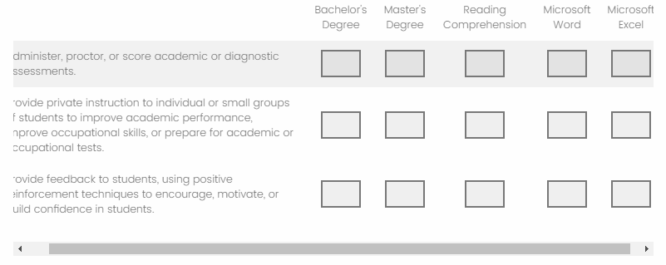



**Appendix C: Task Rating Results**

*Results are presented in order of descending mean scores on the Importance scale.

|  |  |  |
| --- | --- | --- |
|  | *Mean Ratings* | |
| Tasks | Scale A: Importance | Scale B: Frequency |
| 1. Teach students study skills, note-taking skills, and test-taking strategies, using the students' own class materials such as textbooks and notebooks, to help students improve academic performance. | 5 | 4 |
| 1. Review class material with students by discussing text, working solutions to problems, or reviewing worksheets or other assignments to improve the students' understanding. | 5 | 2 |
| 1. Prepare lesson plans or learning modules for tutoring sessions according to students' needs and goals. | 5 | 3 |
| 1. Maintain records of students' assessment results, progress, feedback, or school performance while ensuring confidentiality of all records. | 4.5 | 1 |
| 1. Assess students' progress throughout tutoring sessions to ensure students are improving at an expected rate. | 4 | 2 |
| 1. Provide private instruction to individual or small groups of students to improve academic performance, improve occupational skills, or prepare for academic or occupational tests. | 4 | 3 |
| 1. Provide feedback to students, using positive reinforcement techniques to encourage, motivate, or build confidence in students. | 4 | 2 |
| 1. Participate in training and development sessions to improve tutoring practices or learn new tutoring techniques. | 3.5 | 1 |
| 1. Research or recommend textbooks, software, equipment, or other learning materials to complement tutoring sessions and help students learn tutored material more effectively. | 3.5 | 2 |
| 1. Identify, develop, or implement intervention strategies, tutoring plans, or individualized education plans (IEPs) for students to help optimize the student's learning experience. | 3.5 | 2 |
| 1. Schedule tutoring appointments with students or their parents. | 3 | 1 |
| 1. Communicate students' progress to students, parents, or teachers in written progress reports, in person, by phone, or by email, to keep parents informed of how the student is performing in tutoring sessions. | 3 | 2 |
| 1. Administer, proctor, or score academic or diagnostic assessments to quantify student knowledge or skill. | 3 | 2 |
| 1. Organize the physical tutoring environment, by arranging all materials and equipment used in an orderly fashion, to promote productivity and learning. | Eliminated  (2.5) | Eliminated  (4) |

**Appendix D: Competency Rating Results**

*Results are presented in order of descending mean scores on the Importance scale.

|  |  |  |  |
| --- | --- | --- | --- |
|  | *Mean Ratings* | | |
| Competencies | Scale A: Importance | Scale B:  Need at Entry | Scale C: Distinguishing Value |
| 1. Language proficiency: Ability to speak and understand the language in which the student is learning | 5 | 4 | 5 |
| 1. Knowledge: Knowledge of subjects being taught | 5 | 4 | 5 |
| 1. Education: High School degree | 5 | 4 | 5 |
| 1. Education: College degree (Bachelor’s) | 5 | 4 | 5 |
| 1. Reading Comprehension: The ability to understand writing | 4.5 | 3.5 | 4.5 |
| 1. Encouraging: Be encouraging to the student when the student is struggling to learn material | 4 | 3.5 | 4.5 |
| 1. Perspective-taking: Being able to see things from another person's point of view | 4 | 3.5 | 3.5 |
| 1. Education: College degree (Master’s) | 4 | 4 | 4 |
| 1. Microsoft Word: The ability to use Microsoft Word | 3.5 | 4 | 3 |
| 1. Microsoft Excel: The ability to use Microsoft Excel | 3 | 3.5 | 3 |

**Appendix E: Eliminated Competencies and Rating Results**

*Results are presented in order of descending mean scores on the Importance scale.

*The scores that eliminated the item from final consideration as an essential competency at time of applicant hire are marked with (Eliminated).

|  |  |  |  |
| --- | --- | --- | --- |
|  | *Mean Ratings* | | |
| Competencies | Scale A: Importance | Scale B:  Need at Entry | Scale C: Distinguishing Value |
| 1. Needs Analysis: Diagnose deficiencies in the ability or performance of others | 4.5 | (Eliminated)  2 | 4 |
| 1. Critical Thinking: Using logic and reasoning to identify the strengths and weaknesses of alternative solutions to problems or alternative lines of thinking | 4.5 | (Eliminated)  2 | 4.5 |
| 1. Time Management: Being on time to appointments, ensuring that appointments last long enough to perform all relevant tutoring tasks | 4 | (Eliminated)  2 | 4 |
| 1. Conflict de-escalation: The ability to help calm people down in tense situations | 3.5 | (Eliminated)  2 | 3 |
| 1. Public Speaking: The ability to give public speeches | 3.5 | (Eliminated)  3 | 3 |
| 1. Pedagogical Theory: Understanding the theory behind teaching and learning | 3.5 | (Eliminated)  3.5 | 3.5 |
| 1. Computer Use: The ability to effectively use laptops and desktops | 3 | (Eliminated)  2 | 3.5 |
| 1. Smart Device Use: The ability to effectively use tablets, smartphones, and other smart devices | 3 | (Eliminated)  2 | 3.5 |
| 1. Social Media: Familiarity with social media such as Instagram, Snapchat, TikTok, Facebook, etc. | (Eliminated)  2.5 | (Eliminated)  3 | 2 |

**Appendix F: Interview Notes**

*Notes on this interview are presented in a truncated format. Major questions asked by the interview are presented, followed by notes taken by the interview on the SME’s responses.

***Interviewer*: When you worked as a tutor, did you work independently, though a college or independent agency, or through some other arrangement?**

***Response****:* The SME worked for some time as an independent tutor for middle school children, right after college. The SME also worked for a short time tutoring undergraduate students. He primarily tutored students in math, including algebra, geometry, and statistics.

***Interviewer:* What would you say are the major tasks and activities involved in tutoring others*?***

***Response****:* The major tasks include:

* Teaching others subject matter content
* Running a needs analysis on student
  + This involves diagnosing deficiencies in the tutee’s knowledge, procedural skills, confidence, and more
* Organizational activities
  + Setting and keeping appointments
  + Set location for meetings
* Deciding on the price of tutoring
  + As an independent tutor, the SME set his own prices, based on the length of time spent tutoring

***Interviewer:* How do you think that tutoring affected your other roles at the time (e.g., student, student worker, home life), and vice versa?**

***Response****:* While tutoring as an undergraduate, tutoring did affect his roles as a student. Helping others learn helped him learn how to process information better. Additionally, tutoring helped him have more patience with others during stressful times, and be less confrontational.

***Interviewer:* What major tools or equipment were involved in tutoring?**

***Response****:*Before COVID: Handwritten notes, textbooks. After COVID, Zoom became much more important, as did other electronic communication media (such as using scanners and smart devices to upload pictures of student’s work online) and tablets (for writing on). Other than that, a quiet space was important.

***Interview:* What kind of materials or resources did you use while tutoring?**

***Response:*** Textbooks that were recommended by teachers was a main source of information. Also, the tutor could purchase old exams from schools or students who took classes previously. The SME found that daily worksheets helped students learn effectively.

***Interview:* What language was the tutoring conducted in?**

***Response:*** Usually English (about 90% of the time), because exams were conducted in English; however, sometimes the students needed to speak their native language (usually Mandarin Chinese) to help students understand a concept more easily.

***Interview:* What credentials or qualifications did you need to tutor?**

***Response:*** To tutor middle school students, you needed to be a high school graduate, and it helped to have completed a practicum in tutoring. To tutor college student, it was helpful to have a college degree. All tutors were encouraged to get some formal education on pedagogical techniques.

***Interview:*** **Besides what we’ve already discussed, what KSAOs do you think are necessary for a good tutor to complete the tasks associated with tutoring?**

***Response:***A list of essential KSAOs would be, in no particular order:

* Encourage the learning of others
* Assist in the learning of others
* Perspective-taking: see things from the student’s point of view
* Offer examples of problems to help student understand content more concretely
* Encourage students to bring questions that they have to tutoring sessions so the tutor can discuss them
* A passion for teaching others is helpful!
* Patience with others; conflict de-escalation

**Appendix G: Task-Competency Linkages Results**

|  |  |  |  |  |  |  |  |  |  |  |
| --- | --- | --- | --- | --- | --- | --- | --- | --- | --- | --- |
|  | **Competencies** | | | | | | | | | |
| **Skills** | **1** | **2** | **3** | **4** | **5** | **6** | **7** | **8** | **9** | **10** |
| Teach students study skills, note-taking skills, and test-taking strategies, using the students' own class materials such as textbooks and notebooks, to help students improve academic performance. | 4 | 2 | 3 | 2 | 5 | 3 | 4 | 1 | 2 | 1 |
| Review class material with students by discussing text, working solutions to problems, or reviewing worksheets or other assignments to improve the students' understanding. | 4 | 5 | 3 | 2 | 4 | 3 | 4 | 1 | 2 | 1 |
| Prepare lesson plans or learning modules for tutoring sessions according to students' needs and goals. | 4 | 4 | 3 | 2 | 4 | 2 | 4 | 1 | 3 | 1 |
| Maintain records of students' assessment results, progress, feedback, or school performance while ensuring confidentiality of all records. | 4 | 3 | 3 | 1 | 4 | 1 | 2 | 1 | 2 | 1 |
| Assess students' progress throughout tutoring sessions to ensure students are improving at an expected rate. | 3 | 3 | 3 | 2 | 3 | 3 | 4 | 1 | 2 | 1 |
| Provide private instruction to individual or small groups of students to improve academic performance, improve occupational skills, or prepare for academic or occupational tests. | 4 | 5 | 3 | 2 | 3 | 4 | 4 | 1 | 1 | 1 |
| Provide feedback to students, using positive reinforcement techniques to encourage, motivate, or build confidence in students. | 3 | 3 | 3 | 2 | 3 | 5 | 5 | 1 | 1 | 1 |
| Participate in training and development sessions to improve tutoring practices or learn new tutoring techniques. | 5 | 1 | 3 | 2 | 4 | 2 | 2 | 1 | 1 | 1 |

|  |  |  |  |  |  |  |  |  |  |  |
| --- | --- | --- | --- | --- | --- | --- | --- | --- | --- | --- |
|  | **Competencies** | | | | | | | | | |
| **Skills** | **1** | **2** | **3** | **4** | **5** | **6** | **7** | **8** | **9** | **10** |
| Research or recommend textbooks, software, equipment, or other learning materials to complement tutoring sessions and help students learn tutored material more effectively. | 3 | 4 | 3 | 2 | 5 | 2 | 3 | 1 | 2 | 2 |
| Identify, develop, or implement intervention strategies, tutoring plans, or individualized education plans (IEPs) for students to help optimize the student's learning experience. | 5 | 4 | 4 | 3 | 5 | 4 | 4 | 1 | 3 | 1 |
| Schedule tutoring appointments with students or their parents. | 3 | 1 | 3 | 2 | 3 | 3 | 2 | 1 | 1 | 1 |
| Communicate students' progress to students, parents, or teachers in written progress reports, in person, by phone, or by email, to keep parents informed of how the student is performing in tutoring sessions. | 5 | 4 | 3 | 1 | 4 | 4 | 3 | 1 | 3 | 2 |
| Administer, proctor, or score academic or diagnostic assessments to quantify student knowledge or skill. | 4 | 5 | 4 | 3 | 5 | 2 | 2 | 1 | 1 | 1 |

*Note:* Competency numbers are listed below

1. Language Proficiency: Ability to speak and understand the language in which the student is learning
2. Knowledge: Knowledge of subjects being taught
3. Education: High School degree
4. Education: College degree (Bachelor’s)
5. Reading Comprehension: The ability to understand writing
6. Encouraging: Be encouraging to the student when the student is struggling to learn material
7. Perspective-taking: Being able to see things from another person's point of view
8. Education: College degree (Master’s)
9. Microsoft Word: The ability to use Microsoft Word
10. Microsoft Excel: The ability to use Microsoft Excel

**Appendix H: Task-Competency Linkages Mean Ratings**

**Tasks**

|  |  |
| --- | --- |
| **Tasks** | **Mean Rating** |
| Teach students study skills, note-taking skills, and test-taking strategies, using the students' own class materials such as textbooks and notebooks, to help students improve academic performance. | 2.7 |
| Review class material with students by discussing text, working solutions to problems, or reviewing worksheets or other assignments to improve the students' understanding. | 2.9 |
| Prepare lesson plans or learning modules for tutoring sessions according to students' needs and goals. | 2.8 |
| Maintain records of students' assessment results, progress, feedback, or school performance while ensuring confidentiality of all records. | 2.2 |
| Assess students' progress throughout tutoring sessions to ensure students are improving at an expected rate. | 2.5 |
| Provide private instruction to individual or small groups of students to improve academic performance, improve occupational skills, or prepare for academic or occupational tests. | 2.8 |
| Provide feedback to students, using positive reinforcement techniques to encourage, motivate, or build confidence in students. | 2.7 |
| Participate in training and development sessions to improve tutoring practices or learn new tutoring techniques. | 2.2 |
| Research or recommend textbooks, software, equipment, or other learning materials to complement tutoring sessions and help students learn tutored material more effectively. | 2.7 |
| Identify, develop, or implement intervention strategies, tutoring plans, or individualized education plans (IEPs) for students to help optimize the student's learning experience. | 3.4 |
| Schedule tutoring appointments with students or their parents. | 2 |
| Communicate students' progress to students, parents, or teachers in written progress reports, in person, by phone, or by email, to keep parents informed of how the student is performing in tutoring sessions. | 3 |
| Administer, proctor, or score academic or diagnostic assessments to quantify student knowledge or skill. | 2.8 |

**Competencies**

|  |  |
| --- | --- |
| **Competency** | **Mean Rating** |
| Language proficiency: Ability to speak and understand the language in which the student is learning | 3.9 |
| Knowledge: Knowledge of subjects being taught | 3.4 |
| Education: High School degree | 3.2 |
| Education: College degree (Bachelor’s) | 2 |
| Reading Comprehension: The ability to understand writing | 4 |
| Encouraging: Be encouraging to the student when the student is struggling to learn material | 2.9 |
| Perspective-taking: Being able to see things from another person's point of view | 3.3 |
| Education: College degree (Master’s) | 1 |
| Microsoft Word: The ability to use Microsoft Word | 1.8 |
| Microsoft Excel: The ability to use Microsoft Excel | 1.2 |

1. Occupational Information Network; <https://www.onetonline.org/>
2. The wording in this section was adapted from the California State Personnel Board’s *Merit Selection Manual: Policy and Procedures*, Appendix H.
3. *Note to Sylvia*: In a real-world setting, I would likely suggest that this level of interrater agreement might be too low for the data to be reliable. However, without this data I have no project, and I need to find some sort of justification for their inclusion in the study.